1.SELF JOIN:

It is used to join the data of a table with itself

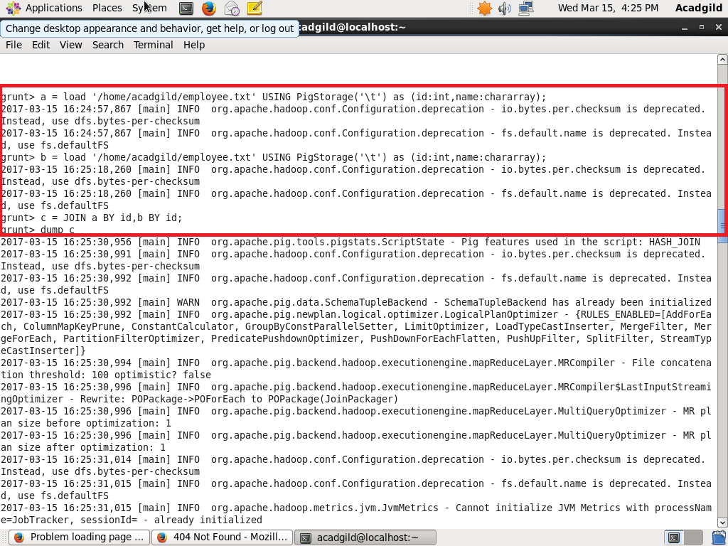

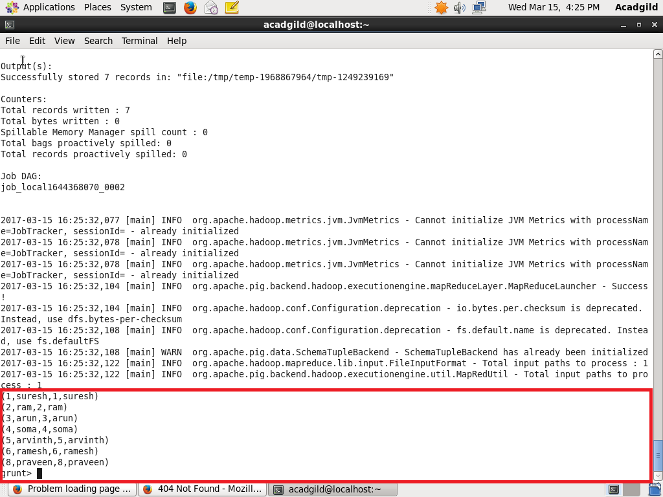

2.INNER JOIN

It is a join used to join 2 or more tables based on the common field mentioned between them  
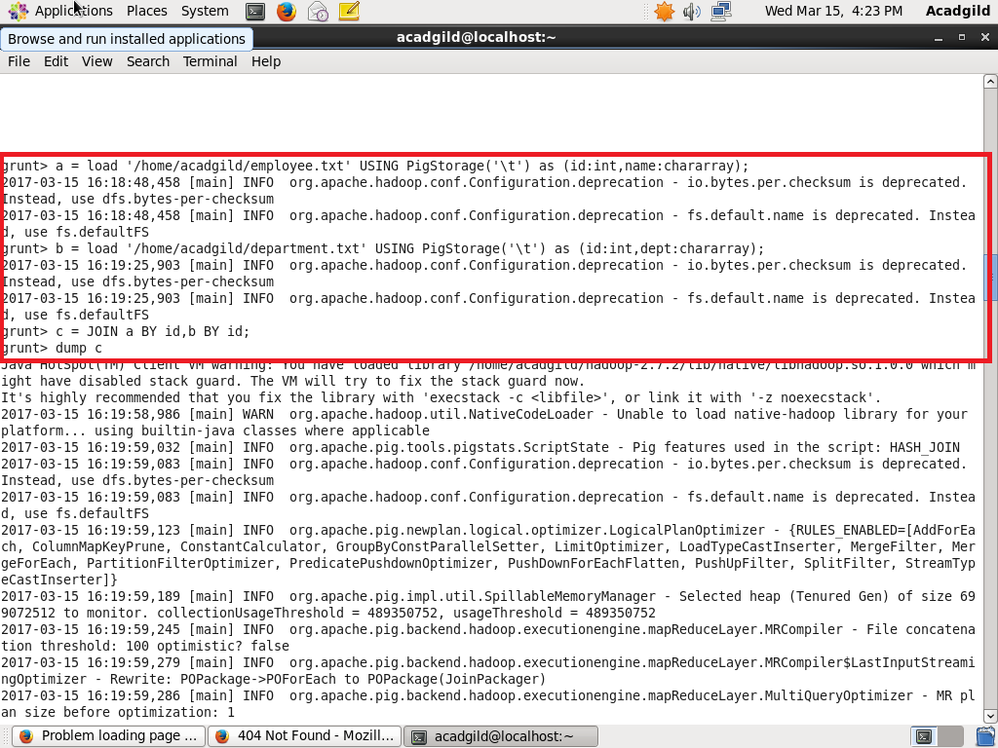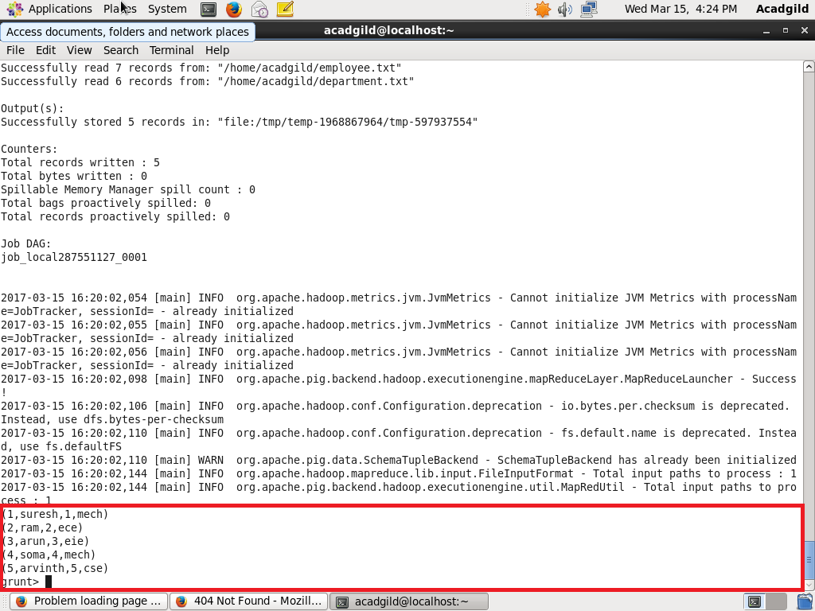

3.LEFT OUTER JOIN

This join returns all the rows from the left table and only matched rows from the right table

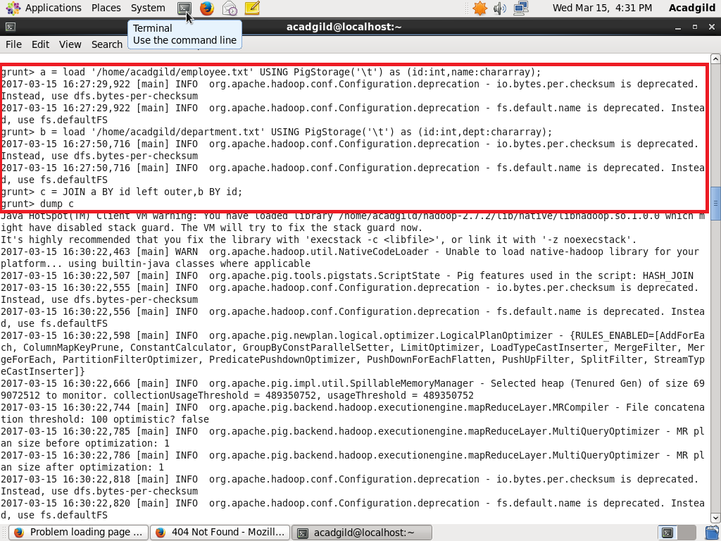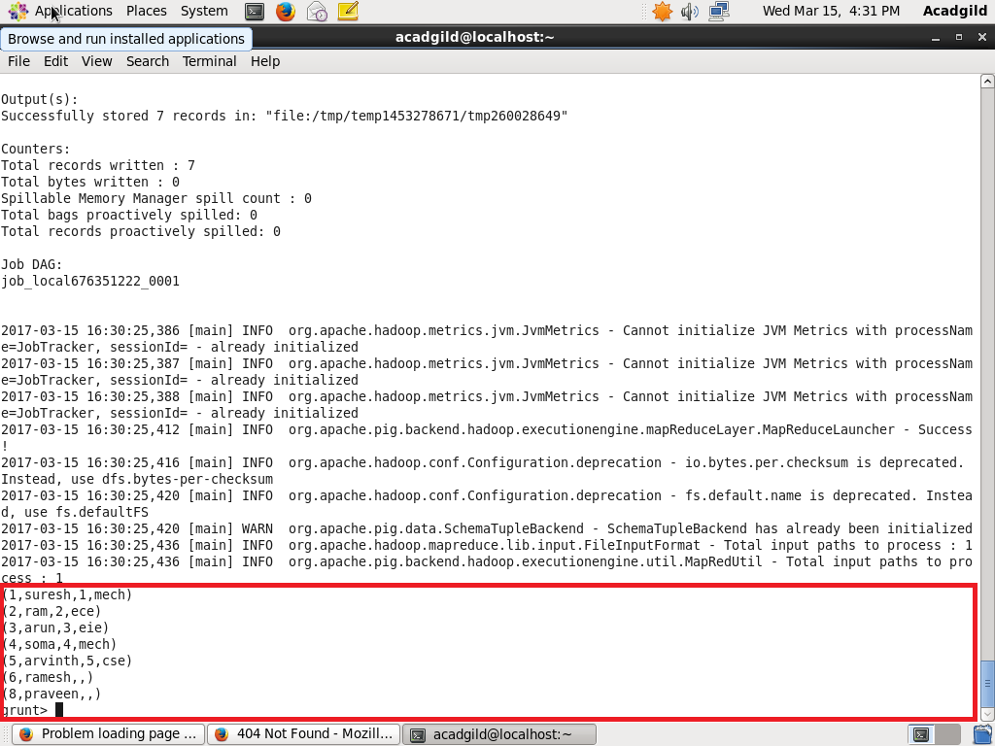

4.RIGHT OUTER JOIN

This join returns all the rows from the right table and only the matched rows from the left table

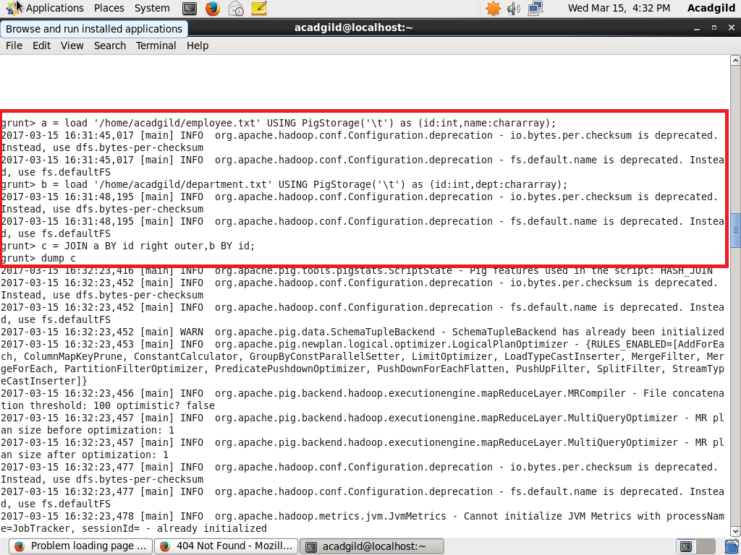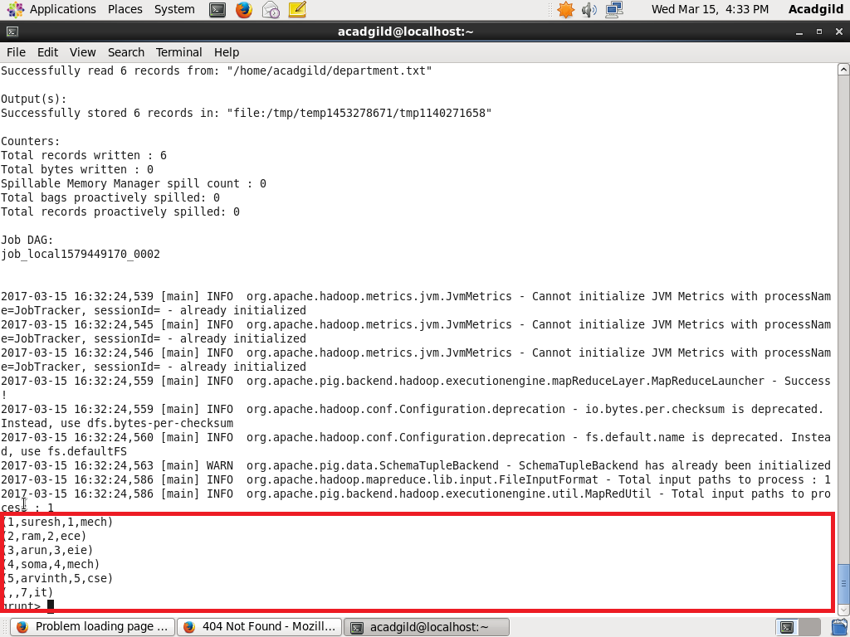

5.FULL OUTER JOIN

This join returns all the rows from both the tables

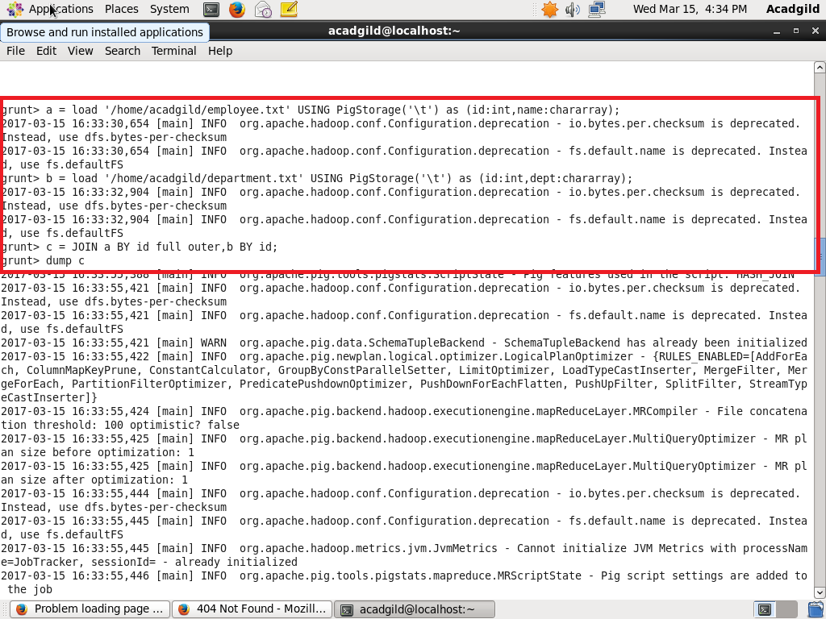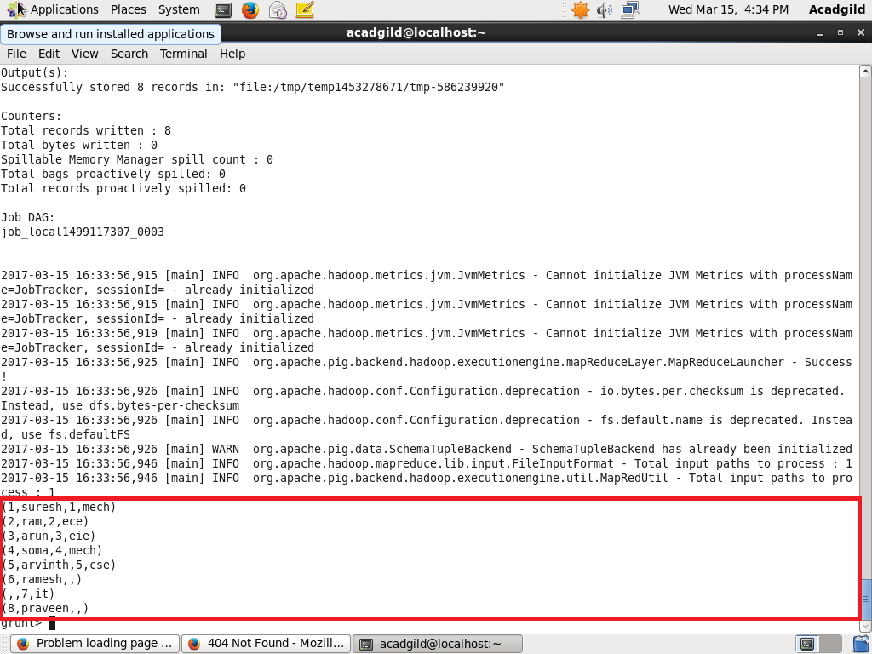

DATASET USED

